00.08
Support Tool
Process Design & AMOS Configuration Document
Purpose
This Process Design document is provided to Key-Users to record their key decisions regarding the AMOS Process design and the required AMOS configuration.
It is updated throughout the Project Definition Phase and used as the baseline for the Final Acceptance prior to Go-Live
Revision
Author, Name | Date | Notes
ADKE Adam Kelemen | 16.05.2024 | First version

Table of Contents
1. Process Overview & Objectives 3
2. Regulatory References 3
3. Definitions & Glossary 3
4. Process Tasks 3
5. Process Dependencies 3
6. Process Flow 4
7. Process Design Questions 5
8. Data (Source) Mapping 6
9. Other Software Used 6
10. AMOS Configuration 7
a. Basic Data 7
b. Parameters 7
c. Workflows 7
d. Scheduled Tasks 7
e. API’s & Interfaces 7
11. Annex – Additional Info 8

Process Overview & Objectives

Process General Description:
This process will help the AMOS Competence Center (ACC) to handle the communication process with Swiss-AS in case there is a request or bug report from the business users which cannot be fulfilled by ACC.
Swiss-AS requests it’s Customers to use the Support Tool in AMOS (APN 1635) in case there are request for different type of support.
This following process categorizes 3 different support categories which are reflected in the Support Tool:
- Request for Bugfixing: if there is bug in the code or if the actual behaviour of AMOS is different than the intended behaviour.
- Request for Customization, Request for Extension or Request for Modification.
This is used when our customers would like to change AMOS behaviour.
- Question
ACC and business users must perform acceptance testing once a solution is provided.

Main Process Objective (Outputs & Outcomes) :

There can be different outcomes of this process:
- Solution provided in a form of patch.
- Solution provided in next AMOS Release.
- Solution provided in text answer or a process description.
- Swiss-AS can reject sometimes due to different reasons.
Main stakeholders in the process are:
- ACC: must manage support communications also must deploy and test solutions provided.
- Business users: perform acceptance testing with ACC. They must accept the solutions.
- Swiss-AS: provides answers, solutions.

Regulatory References

- -

Definitions & Glossary

Key-Words | Explanation
ACC | This acronym relates to the AMOS Competence Centre.
Business Users | The people who work in AMOS.
Patch | Small software upgrade, issued weekly by Swiss-AS.
Release Change | Large software upgrade. New release issued twice per year by Swiss-AS. Usually its a small project to perform a release change.

Process Tasks

Business Process Task / Actions / Activities :
- Open support case, make sure to phrase clearly and specifically your request so there is no chance for misunderstanding. Include as much details as possible, usually this reduces response times.
- In case you want to change AMOS, consider using your AMOS Chips. This is a method Swiss-AS implemented mainly for it’s live Customers to be able to vote certain support cases. This is a way to possibly fast track certain change requests by joining forces with other customers.
Chip distribution to Customers is decided by Swiss-AS and depends on the contract volume.
- In case of change requests, ACC and the business must approve the CAR (Change approval request).
- ACC and business users must perform acceptance testing.

Process Dependencies

- Support tool is usually configured at AMOS installation by Swiss-AS for AOS and Hosting customers. This is the only dependency.

Process Flow
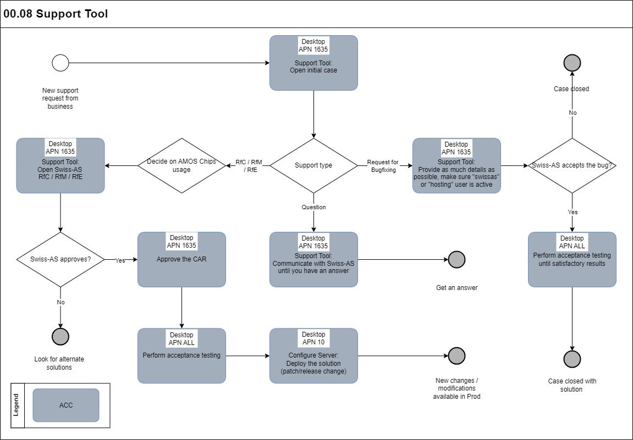

Process Design Questions

# | Question | Answer
1
2
3
4
5
6

Data (Source) Mapping

Data Sources | Description | Volume / Manual / Automatic / Static / Dynamic
Support Cases | You can browse other Customers public support cases | Dynamic

Other Software Used

Other Softwares | Used by: | Description
Internet Browser | ACC or Business | AMOS Support tool is available in the browser with your customer portal login:  https://www.swiss-as.com/webSupportTool/

AMOS Configuration

Add comments about the AMOS Configuration

Basic Data

Basic Data Table | Notes
-

Parameters

Parameter Code | Parameter Name | Notes
1197 | Support-Tool: USE SUPPORT-SERVER TO SEND MAILS
1467 | FOLDER FOR SUPPORT QUERY SCREENSHOTS

Workflows

Workflow Number | Workflow Name | Notes
-

Scheduled Tasks

Scheduled Task Reference | Frequency | Notes
-

API’s & Interfaces

Reference | Direction | Trigger | Frequency
-

Annex – Additional Info

